Chapter 1, Problem 3.

Find the charge q(t) flowing through a device if the current is:
(a) 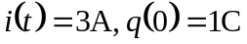
(b) 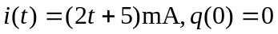
(c)
(d) 